**Chapter 3 hardware**

**Input device and sensor**

1. **Keyboard**

* A keyboard is like a miniature computer. It has its own processor and circuitry that carries information to and from that processor.
* When you press a key, it presses a **switch**, completing the circuit.

When the processor finds the circuit, it compares the location of that circuit on the key matrix to the **character map** in its read-only memory (ROM)

* The problem:

Frequent use of these devices can lead to injuries, such as Repetitive Strain Injury(RSI) in the hands and wrists.

* Solve the problem:

Ergonomic keyboard can help to overcome this problem, they are designed to give more support to the wrists and hands when doing typing.

1. **Optical mouse**

The optical mouse actually uses a tiny camera to take 1,500 pictures every second. Able to work on almost any surface, the mouse has a small, red light-emitting diode (LED) that bounces light off that surface onto a complementary metal-oxide semiconductor (CMOS) sensor.

**The process**

The CMOS sensor sends each image to a digital signal processor (DSP) for analysis.

Based on the change over a sequence of images, the DSP determines how far the mouse has moved and sends the corresponding coordinates to the computer.

The computer moves the cursor on the screen based on the coordinates received from the mouse.

**Benefit of optical mouse**

* No moving parts means less wear and a lower chance of failure.
* There's no way for dirt to get inside the mouse and interfere with the tracking sensors.
* Increased tracking resolution means smoother response.
* They don't require a special surface, such as a mouse pad.

1. **Trackerball**

Trackballs work by using optical sensors to read the movements of dots on the surface of the ball. By tracking the direction in which the dots move, the optics translate the movement of the ball into moving the cursor.

**Advantage and disadvantage**

* Advantage:

A trackball does not require any desk space for use since many are handheld.

Using a trackball has been compared to a joystick, and both are generally preferred by people who find their arm movements are unsteady when using a mouse.

* Disadvantage：

It has a large size in comparison to a mouse.

Trackballs also cost more and have a narrower range of options than other input peripherals.

1. **Microphone**

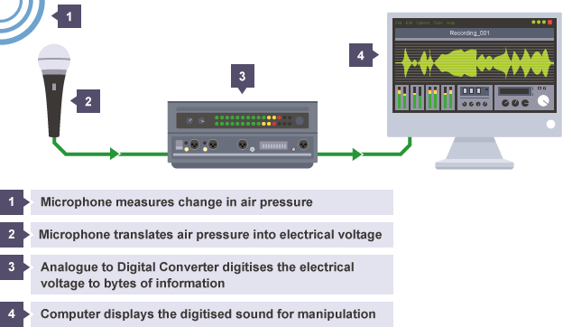

1. **Scanners**

* The image is placed before the carriage, consisting of a light source and sensor.
* The amount of light transmitted through the image and picked up by the sensor, is then converted to a voltage.
* Translate the voltage to digit signal by analogue-to-digital conversion (ADC).

**Optical Character Recognition**

* When a page of text is scanned into a PC, it is stored as an electronic file made up of tiny dots, or pixels.
* In order to turn the group of pixels into editable words, the image must go through OCR.
* OCR programs which use the pattern matching method have bitmaps stored for every character of each of the different font and type sizes.
* By comparing a database of stored bitmaps distributed to the bitmaps of the scanned letters the program attempts to recognise the letters.

1. **Touchscreens**

**i Resistive touch screen**

* A resistive touchscreen comprises of several layers(flexible plastic and glass layers)
* The front surface of resistive touchscreen panel is a scratch-resistant plastic layer.
* The second important layer is either made of glass or hard plastic.
* Both the layers are separated with a thin gap in between.
* An electrical resistance is created between both the layers that charge runs from top to bottom in one layer and side-to-side in another.
* When a finger or stylus tip presses down on the outer surface, both the ITO films meet. It is the measure of the resistance of both the layers at point of contact, which leads to get an accurate measurement of the touch position.

**Advantages and disadvantage**

Advantage

* Low production cost
* High resistance to dust and water
* Best used with a finger, gloved hand or stylus
* Best suited for handwriting recognition

Disadvantages

* Not too sensitive, you have to press down harder
* Poor contrast because of having additional reflections from extra layer of material placed over the screen
* Does not support multi-touch

**ii Capacitive touch screen**

* In the capacitive system, a layer that stores electrical charge is placed on the glass panel of the monitor.
* When a user touches the monitor with his or her finger, some of the charge is transferred to the user, so the charge on the capacitive layer decreases.
* This decrease is measured in circuits located at each corner of the monitor. The computer calculates, from the relative differences in charge at each corner, exactly where the touch event took place and then relays that information to the touch-screen driver software.

**Advantages of Capacitive Touchscreen**

* Because capacitive touchscreen has glass layer instead of plastic, it looks brighter and sharper
* Highly touch sensititive and doesn’t need a stylus
* Supports multi-touch

**Disadvantages of Capacitive Touchscreen**

* Because the technology is dependent on the conductive nature of human body, it doesn’t work if the user is wearing gloves
* Glass is more easily to breaking
* Because of having a complex structure, these are quite expensive

1. **Automatic data capture**
2. Optical character recognition（OCR ） （光学字符阅读器）

Computer equipped with optical character recognition(OCR) software allow the scanned text from the document to be converted into a TEXT file format.

2.Optical mark reader（OMR ） （光标阅读机）

3.Magnetic ink character recognition（MICR） （磁墨水字符识别）

4.Radio-frequency identification(RFID) tag reader （射频识别目标阅读器）

5Magnetic stripe reader（磁条阅读机）

6.Smart card reader（智能卡读卡器）

7.Biometric data capture devices（生物识别数据捕捉设备）

**2. Sensor**

**You should be aware of the different types of sensor used in a wide variety of control and monitoring applications**

* Temperature(温度) sensor
* Humidity\moisture(湿度) sensor
* Light(灯光) sensor
* Pressure(压力) sensors
* Infrared(红外线) sensor
* Microwave (微波) sensor
* Gas(气体) sensor

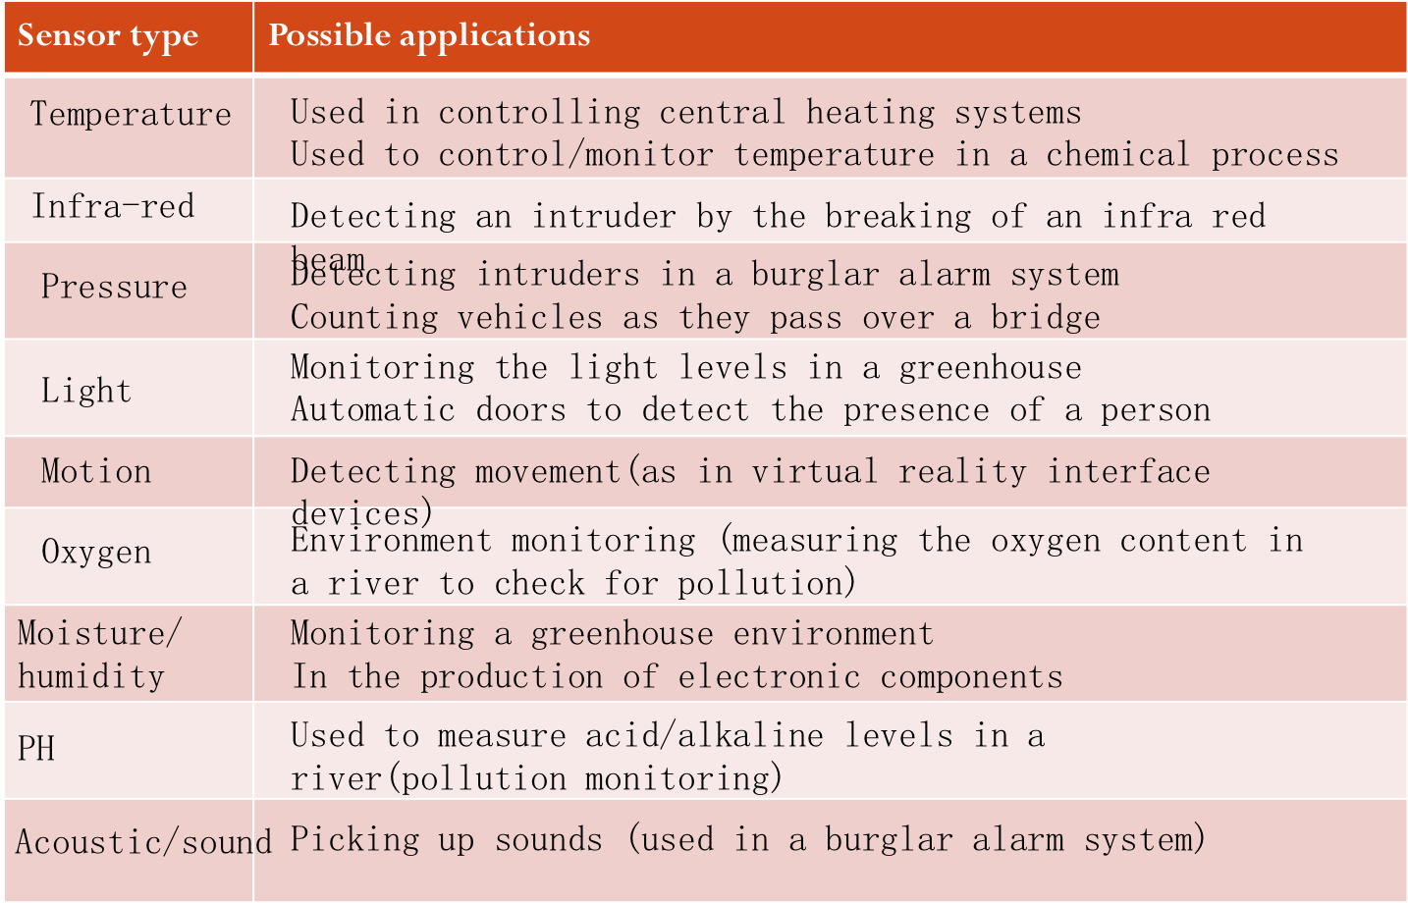

**3. Monitoring and control**

**(1) EXAMPLE—— monitoring(a burglar alarm system)**

* Gather data from sensors(pressure, infra-red, motion) in the house
* Signal are sent to an ADC where they are converted into digital
* The digital information is then sent to the computer
* The computer compares this information with pre-set data
* If it is out of range (example, pressure too high, beam has been broken, etc) then a signal is sent to sound an alarm
* Alarm continues to sound until system is re-set
* System continues to monitor sensors until turned off

**(2) EXAMPLE—— control (a chemical process)**

* Gather data from sensors(temperature, pressure) from the reactor vessel
* Signals are sent to an ADC where they are converted into digital
* The digital information is then sent to the computer
* The computer compares this information with pre-set data
* if temperature<80o a signal is sent to an actuator to switch on the heater
* If pressure < 2 bar a signal is sent to an actuator to open the valve.
* DAC is used to convert signals to analogue to control heater and valves.
* This continues until the chemical process is completed.

**(3) Why is this done?**

* it is safer (even though humans can work in shifts there is always the danger of missing information at shift handover etc.)
* Computers can run 24 hours a day, 365 days a year. (faster response to non-standard conditions and they don’t get tired)
* computers are more accurate and can take more frequent readings (e.g. if readings need to be taken every 30 seconds, humans can make mistakes or miss readings or even find it is impossible to take readings at a short time intervals)
* data can be automatically displayed and analysed without the need to enter data manually (which in itself could introduce errors into the system)

**Output device**

1. **Inkjet printer**

* A sheet of paper is fed in
* The print head moves across the sheet depositing ink on to the paper
* The paper is moved forward a fraction and the print head carries out another traversal until the sheet has been fully printed
* Inkjet printer print the page line by line

**The advantage**

* Cheaper
* Image quality can be excellent when used with photographic paper

**Disadvantage**

* Expensive to run as they can use a lot of ink
* Image quality can be poor when printing on ordinary paper
* It is difficult to print on both sides of paper
* They are slow at printing

1. **Laser printer**

* The light reflects off the page onto a light-sensitive drum, it erases the positive charge and creates an area of negative charge instead.
* The toner has been given a positive electrical charge, so it sticks to the parts of the photoreceptor drum that have a negative charge
* A sheet of paper feeds up toward the drum, as it moves along, the paper is given a strong positive electrical charge
* When the paper moves near the drum, its positive charge attracts the negatively charged toner particles away from the drum.
* The heat and pressure from the rollers fuse the toner particles permanently into the fibers of the paper.
* Laser printer print the whole page in one go

**The advantage**

* Cheap to run
* Text printing quality is excellent
* It is quick at printing
* It is suitable for duplex printing, this reduces paper costs

**Disadvantage**

* It is expensive to buy
* Image printing quality on photographic paper is not as good as inkjet printer

1. **3D printer**

* 3D design created in a suitable computer aided design(CAD) package
* The design is split into layers
* 3D printer uses a nozzle to squirt material on to the printed bed to create a physical layer to match the design
* This process is repeated
* The solid object is built up layer by layer using materials such as powdered resin, metal or paper.

**The advantage**

* Bespoke items can be made quickly
* Any shape can be printed
* Costs to a designer can be reduced as they can easily re-print it
* Design can be shared by sharing the digital file

**Disadvantage**

* Expensive
* It is not durable
* Dangerous items may be printed
* Copyright issues may exist

1. **Loudspeakers/headphones**

Sound is produced from a computer by passing the digital data through a digital to analogue converter (DAC) and then through an amplifier, finally the sound emerges from a loudspeaker.

**Memory**

1. **Primary memory (e.g. RAM, ROM)**
2. **RAM means random access memory.**

It is volatile memory (the contents of the memory are lost when the power to the RAM is turned off)

It is used to store data, files or part of the operating system that are currently in use

It can be written to or read from and the contents of the memory can be changed.

RAM is much faster to write to or read from than other types of memory, but its main drawback is its volatility

Two types of RAM

i Dynamic RAM (DRAM) 动态随机存储器

* DRAM chip is constructed from transistors and capacitors 电容器 which leak electricity, so It needs to be constantly refreshed (every 15 microsecond).

ii Static RAM (SRAM) 静态随机存储器

* SRAM is constructed from flip-flops 触发器 which continue to store data indefinitely while the computer system is switch on, so it does not need to be refreshed.
* It has more parts, a static memory cell takes up a lot more space on a chip than a dynamic memory cell. Therefore, you get less memory per chip, and that makes static RAM a lot more expensive.

iii The features of SRAM

* It is faster than DRAM (access time for SRAM is 25 nanoseconds and for DRAM is 60 nanoseconds)
* More expensive
* Less capacity

iv The features of DRAM

* They are less expensive to manufacture than SRAM
* They have a higher storage capacity than SRAM
* They consume less power than SRAM

1. **ROM means read only memory.**

ROM holds data that are non-volatile. Once data have been written into a ROM chip, they cannot be changed. The ROM often holds the instructions for starting up the computer

1. **The compare between primary storage and secondary storage**

|  |  |
| --- | --- |
| Primary storage | Secondary storage |
| Directly accessible by the processor as it is internal to the computer | Not directly accessible to the processor |
| Temporarily stores data | Permanently stores data |
| Can be read from and written to primary storage almost instantly | Slower to read data from and write data to, as it needs to be transferred into RAM first |
| Normally a few gigabytes in capacity | Can be up to a terabyte or more in capacity |
| Fixed within the computer | Some devices are removable |

1. **secondary memory**
2. **Magnetic storage (磁性存储)**
3. **Hard disk drive (HDD)**

* Data is stored in a digital format on the magnetic surfaces of the disks.
* Latency 延时 is defined as the time it takes for a specific block of data on a data track to rotate around to the read-write head. User will notice that ‘please wait’or ‘not responding’

1. **Removable hard disk**
2. **magnetic tape**
3. **solid state storage**
4. **Solid State Drives (SSDs)**

* SSDs remove latency issue, they have no moving parts and all data is retrieved at the same rate.
* Solid state storage device store data by controlling the movement of electrons within NAND chips. It is non-volatile rewritable memory.

**The benefits of using SSD**

* They are considerably lighter(which make them suitable for laptops)
* They have a lower power consumption(which make them suitable for laptops)
* They run much cooler than HDDs(which make them suitable for laptops)
* They are more reliable (no moving part to go wrong)
* Data access is faster than HDD

**The drawback of SSD**

* Questionable longevity of the technology, most solid state storage devices are rated at only 20 GB write operations per day over a three-year period

**(ii) USB flash memory**

* They are very small, lightweight devices which make them as a method for transferring files between computers

1. **Digital storage cards**

* Each memory card is made up of NAND chips, and as with all solid-state memories, there are no moving parts.

1. **Optical storage (光学存储)**
2. **CD（compact disc）**It can store 700 MB of data
3. **DVD（digital versatile disc）**It can store 4.7 GB of data

**Why DVD has lager capacity than CD?**

* DVD use the dual-layering which increase the storage capacity.
* DVD ‘s ‘pit’ size and track width are smaller, this means more data can be stored on the DVD surface
* DVD use lasers with a wavelength of 650 nanometres 纳米; CD use lasers with a wavelength of 780 nanometres, the shorter the wavelength of the laser light, the greater the storage capacity of the medium.

1. The types of optical media

* CD-ROM/ DVD-ROM (the data is already burned onto the disk. It can only be read)
* CD-R / DVD-R (write once only)
* CD-RW / DVD-RW (can be written to or read from many times)
* DVD-RAM
* It uses a number of concentric tracks which can allow read and write operations at the same time to take place
* They allow numerous read and write operations and have great longevity which make them ideal for archiving

1. **Blu-ray disks**

They are different to DVDs in their construction and in the way they carry out read-write operations.

The main difference:

* A blue laser (rather than red laser) is used to carry out read and write operations
* Using blue laser light means the ‘pits’and ‘bump’ can be much smaller, so it can store up to 5 times more data than DVD
* Blu-ray uses a single 1.1 mm thick polycarbonate, DVD uses a sandwich of two 0.6 mm thick disks
* Blue-ray uses only one layer, so it don’t suffer from birefringence (双折射)
* Blu-ray disks come with a secure encryption system which helps to prevent piracy and copyright issue.

1. **The difference between CD,DVD and blu-ray**

